Clinical Management of Military Working Dogs

**MANAGEMENT OF SHOCK IN MILITARY WORKING DOGS**

**1.** Shock in deployed MWDs will most likely be due to hemorrhage from trauma or hypovolemia due to severe protracted dehydration from gastrointestinal losses. ***As with*** ***human patients, the stepwise approach in MWDs is to control bleeding (if present) and*** ***then stabilize the patient using targeted fluid therapy***.

**2. Immediate hemorrhage control in trauma cases**.

MWDs will likely be presented for follow-on care after the handler has already provided emergent care for severe bleeding. Handlers are trained to use direct pressure, pressure dressings, and QuikClot™ Combat Gauze® for severe extremity bleeding; tourniquets are not routinely used in MWDs due to anatomical difficulties in placement. However, some MWDs may present with untreated extremity hemorrhage, or with ―hidden (intracavitary) hemorrhage that must be addressed by the FMA.

a. Assess for unrecognized hemorrhage and control all sources of external bleeding. Use

direct pressure initially, or rapidly clamp and legate major vessels if traumatized. Dogs

have excellent collateral circulation, and paired major vessels can be legated without

concern for tissue ischemia or edema, to include the femoral arteries and veins, external

jugular veins, external carotid arteries, and brachial arteries and veins.

b. Tourniquet use on the limbs of dogs is challenging, due to the anatomic shape of the

canine leg. Experience has shown that conventional tourniquets designed for human

adults do not remain in place or effectively control hemorrhage very well when used on

dogs. Thus, avoid these tourniquets for extremity bleeding. Some success is reported in

use of improvised tourniquets, such as surgical rubber tubing or constrictive gauze

bandage placement to abate extremity arterial hemorrhage. If delay in definitive care of

major extremity trauma is expected, use hemostatic agents, direct pressure, and

compressive bandaging to assist with hemorrhage control.

**3. Clinical signs of shock in MWDs**. Dogs in shock are amazing in how stable they can appear on initial presentation, due to compensatory mechanisms.

a. MWDs in early (compensatory) shock may have tachycardia, tachypnea, alert mentation, rapid arterial pulses with a normal or increased pulse pressure, decreased capillary refill time (< 2 seconds), and normal or bright red mucous membranes. While this MWD seems ―normal,‖ it is already in compensatory shock. Immediate treatment at this point may stop the progression of shock.

b. As the early decompensatory phase of shock begins, tachycardia persists, pulse pressure and quality begins to drop or may be ―normal,‖ capillary refill time becomes prolonged, mucous membranes appear pale or blanched, peripheral body temperature drops, and mental depression develops. Aggressive treatment must be provided to halt ongoing shock.

c. As late decompensatory shock develops, the heart rate drops despite a decreased cardiac output, capillary refill time is very prolonged or absent, pulses are poor or absent, both peripheral and core temperature is very low, and marked mental depression (stupor) is present. Irreversible cellular injury may be present to such a severe degree that despite aggressive measures at this point, many patients will die.

**4. The standard therapy for shock in MWDs** includes providing immediate fluid therapy

targeted to specific endpoints, providing supplemental oxygen, and identifying and treating

the cause for the shock.

a. Provide immediate fluid therapy. (These steps should only be performed in the FMA has received the appropriate training from a Licensed Veterinarian)

1) Place multiple large-bore intravenous catheters, perform venous cut-down, and/or place intra-osseous (IO) catheters.

a) Do not delay in placing catheters - if one percutaneous attempt is not successful in a shock patient, immediately choose an alternate percutaneous site and assess the need for IO catheterization. The cephalic veins and external jugular veins are ideal for peripheral catheterization.

b) The proximal lateral humerus and proximal craniolateral tibia are ideal for IO

catheter placement, using the same technique as for people. To avoid bicortical

placement of IO catheters (and thus ineffective fluid delivery), use pediatric

(15mm X 15 gauge) IO catheters in dogs weighing less than ~40 pounds and adult

(25mm X 15 gauge) IO catheters in dogs weighing more than ~40 pounds.

2) Give crystalloid fluids as the first-line treatment. Normosol-R® or Plasmalyte-A® are optimal for dogs; however, saline or LRS are acceptable in emergent cases.

3) Be prepared to administer up to 90 mL/kg of crystalloids in the first hour Aggressive, but careful, fluid delivery, with frequent reassessment of the patient‘s status, is critical. Most MWDs can be successfully resuscitated with much less than this calculated maximum volume. For MWDs, use graduated challenge boluses and assess response to therapy carefully. In MWDs, **use the “10-20-10-20 Rule”**. For example, a 40 kg MWD might need 3.6 L of fluids in the first hour to treat shock, but should be given quartershock volumes of 900 mL every 10-20 minutes during initial resuscitation, based on response.

**Shock Fluid Therapy Protocol of MWDs - The “10-20-10-20 Rule”**

1. Calculate total ―shock volume‖ of fluids (90 mL/kg) that might be required.

2. Collect baseline physiologic and clinical data (mentation, NIBP, HCT, TP, HR, pulse quality,

CRT, mucous membrane color).

3. Give one quarter of the calculated ―shock‖ volume over the first **10** minutes.

4. Reassess the patient‘s pulse quality, CRT, mucous membrane color, heart rate, NIBP, etc.

5. Give another one quarter of the calculated ―shock‖ volume over the next 10-**20** minutes, if

necessary.

6. Reassess baseline data.

7. If HCT > 20% and TP not below 50% of starting value, and further fluid therapy is required, then

give another one quarter of the calculated ―shock‖ volume over **10** minutes.

8. Reassess baseline data.

9. If fluid therapy is still required, give the final one quarter of the calculated ―shock‖ volume over

10-**20** minutes.

4) Give a **hydroxyethyl starch (HES) IV or IO bolus of 10-20 mL/kg over 5-10**

**minutes** if clinical signs of shock do not abate after the first 30 minutes (first 2

quarter-shock IV challenges) of crystalloid fluids, or response to crystalloid

challenges is not sustained. Repeat this bolus if no response to therapy. **Do not give**

**human serum albumin or other synthetic colloids (e.g., dextrans) to MWDs.**

5) Give a **hypertonic saline (HTS) IV bolus of 4 mL/kg over 5 minutes** (if 7-7.5%

HTS is available) for MWDs that fail to respond to two or three quarter-shock boluses

of crystalloids and/or one or two boluses of HES.

6) **Blood product transfusions for MWDs are only available from Veterinary**

**Service Support units and their administration is only authorized under the**

**direct supervision of a Veterinarian.** Human blood products and albumin, or other

animal blood products, must never be given to dogs, given the high risk of

anaphylactic reactions.

7) Targeted shock resuscitation endpoints that are practical for HCPs in the deployed

setting include systolic and mean arterial pressures, level of consciousness/mentation,

mucous membrane color and capillary refill time, HR, RR, and pulse quality.

a) ***Target a MAP >65 mmHg or a Sys >90 mmHg***. Note that neonatal or pediatric

blood pressure cuffs must be used.

b) Target normal level of consciousness (LOC) and an alert mentation.

c) Target light pink-to-salmon pink MM and a CRT <2 seconds.

d) Target a HR that is 60-90 beats per minute at rest with a strong, synchronous pulse quality.

e) Target a respiratory rate at rest of 12-40 breaths per minute with normal effort.

8) Once shock has abated, continue IV crystalloid fluids at 3-5 mL/kg/hour for 12-24 hours to maintain adequate intravascular volume.

b. Provide supplemental oxygen therapy. Oxygen supplementation is critical. Every shock patient should receive supplemental oxygen therapy until stable.

c. Identify and treat the cause of shock. The cause of shock must be corrected, if possible.

1) Patients with massive intraabdominal or intrathoracic bleeding need surgery to find the site of bleeding and surgically correct the loss of blood. There may be instances in which emergent thoracotomy or laparatomy are necessary by HCPs to afford a chance at patient survival. Providers must note that emergent surgical management should be considered only if 1) the provider has the necessary advanced surgical training and experience, 2) the provider feels there is a reasonable likelihood of success, and 3) the provider has the necessary support staff, facilities, and monitoring and intensive care facilities to manage the post-operative MWD without compromising human patient care. Thus, emergent surgical management should be considered only in Level 2 or higher medical facilities and by trained surgical specialists with adequate staff.

**NOTE: Direct communication with a US military veterinarian is essential before considering fluid management, and during and after surgery, to optimize outcome. If no communication is available, the FMA will use his/her best judgment in conjunction with the assistance and aid of the MWD handler to provide care for the animal. At no time shall the FMA deviate from the guidelines in a manner that would be proven to be unsafe for personnel or equipment (i.e. crew, passengers, handler, medical gear, or aircraft).**

**EMERGENCY AIRWAY MANAGEMENT IN MILITARY WORKING DOGS**

**1.** Respiratory distress develops in MWDs most commonly due to trauma. MWDs in respiratory distress are fighting to get oxygen: they are anxious, usually have obvious problems breathing, usually have their head and neck extended, elbows and upper legs held out from the chest, don‘t want to lie down, and fight restraint and handling. Cyanosis, if present, is a late finding.

**2.** MWDs in respiratory distress typically have 1 of 3 characteristic breathing patterns that help localize the problem. The following presents a clinical algorithm for differentiating the most likely cause of a patient‘s distress based on the pattern of breathing.

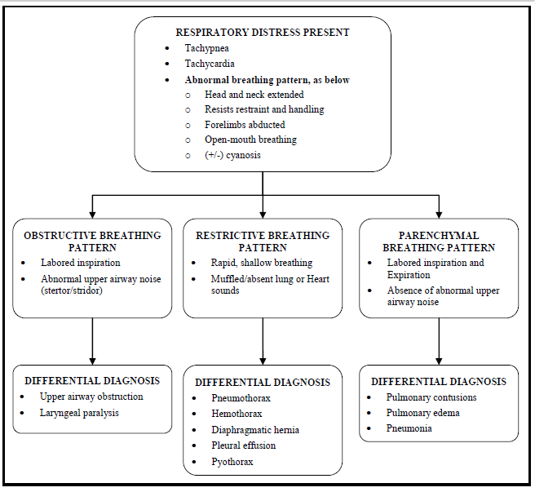

**Oxygen supplementation is essential.** Provide 100% oxygen to all trauma patients and any patient that is showing signs of respiratory distress, until proven unnecessary. Oxygen cages (makeshift or manufactured) and oxygen tents are impractical or not available in the typical medical evacuation setting, so evacuate the MWD to the supporting veterinary facility if long-term oxygen therapy is necessary.

1. Conscious MWDs: Use face mask or ―blow by technique (hold end of oxygen tubing or circuit as close to nose and mouth as possible or attach to muzzle) using high flow rates of 10-15 L/min. **Use caution; ensure handler has control of the MWD at all times.** **Agitated, distressed or dyspneic MWDs will bite and can cause serious injury to the** **FMA or MWD handler.** The following shows simple yet effective techniques to safely provide ―blow by oxygen supplementation to muzzled MWDs.



1. Unconscious MWD: Tracheal insufflation, orotracheal intubation, or tracheostomy should be used to provide supplemental oxygen. These are clinical skills that WILL ONLY BE ATTEMPTED if the FMA has received the appropriate training and evaluation from a licensed veterinarian and a memorandum of agreement has been established between the veterinarian and the unit medical director. 68WF2 Flight Paramedics currently receive training in these areas during Phase 2 of the CCEMT-P training at Joint Base San Antonio, US Army Medical Center and Schools. However, these skills should not be performed until the FMA has shown competency and a MOA has been signed by the medical director and the local veterinarian.